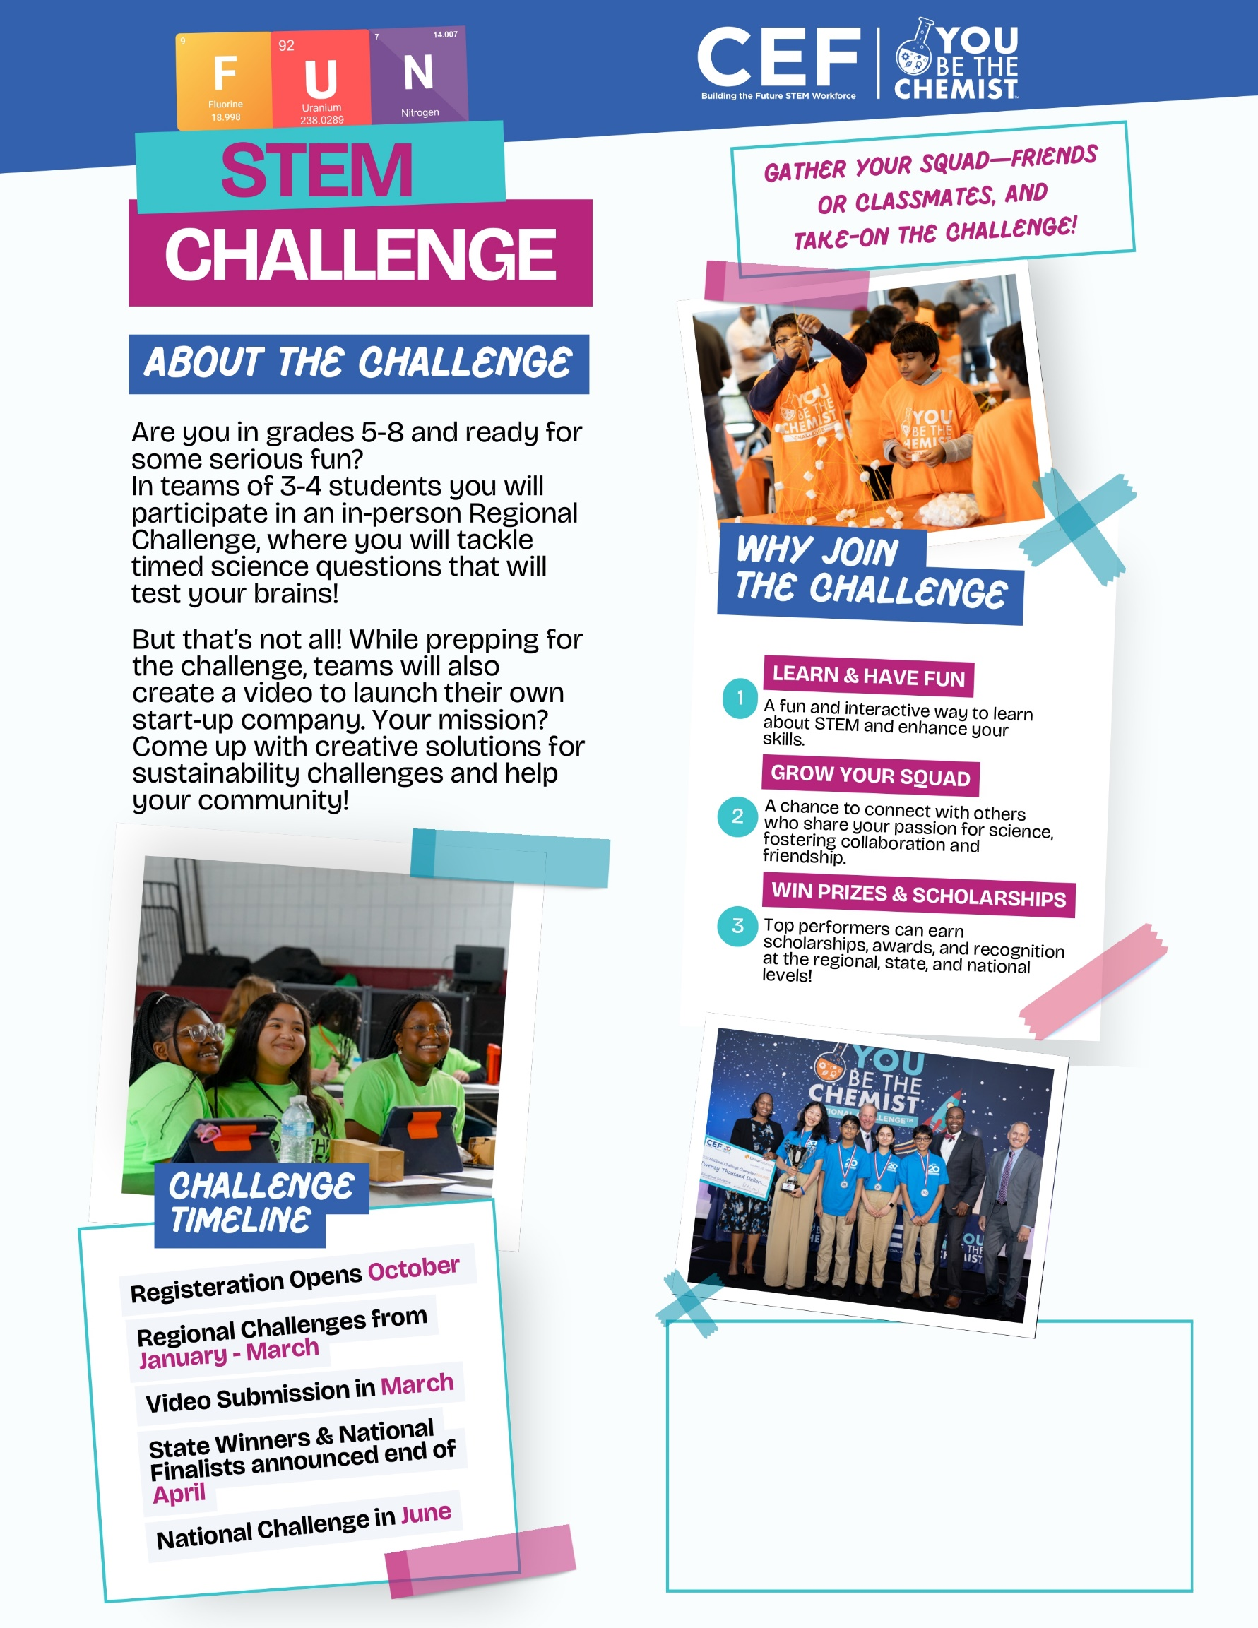

ADD YOUR OWN TEXT HERE!
It could include a link or QR code directing students to a form to express interest, as well as your name or room number for any questions or further information.

